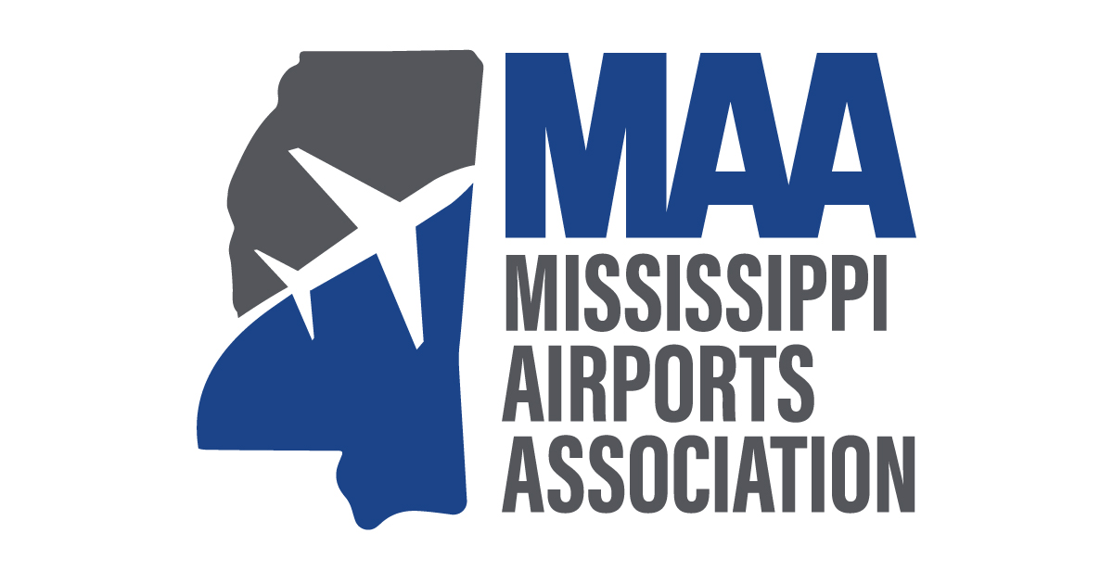
P. O. Box 16803 • Jackson, Mississippi 39236 • 877-397-3929
June 10, 2022
Dear Airport Executive or Government Official,
I find that you are not currently listed as a member of the Mississippi Airports Association (MAA). I am contacting airports in the state to solicit interest in becoming a member of MAA and to participate in our association’s activities in support of airports and aviation in the state of Mississippi. As a board member of MAA, I would like to take a moment to tell you about the good work our association is doing to promote airports and aviation across our region, and how we might best serve you and your organization.
Two of our chief goals are to meet with legislators to encourage increased funding in the Multimodal program for airports and to promote airports and their economic impact.
The Mississippi Airports Association is a consortium of individuals and organizations interested in enhancing aviation in Mississippi. Members include those involved in airport management as well as consultants, businesspeople and members of government. The purpose of MAA is to promote aviation and airport interests, to provide a medium for discussion by its members, to promote proper legislation for aviation and airports and to advise and give consultation to its members when requested. Our annual conference is a great place to network with all involved in aviation in the state of Mississippi. We work hard each year to create meaningful events that add real value for our members, and the conference provides the highest quality programming to connect you with the right people and trends in the industry.
Following is a summary of the benefits of membership in the Mississippi Airports Association:
- Being an integral part of promoting proper legislation for aviation and airports
- Communicating with other aviation professionals to promote best practices
- Participation in the annual conference
- Opportunity to receive and contribute to MAA’s quarterly e-newsletter with a distribution of more than 550 businesses and individuals
- Networking with airport directors and those with whom they do business
We invite you to visit our website https://www.msairportsassociation.com for further information. Our website accommodates online membership registration at https://www.msairportsassociation.com/membership-applications.
Most Sincerely,

Wes Kirkpatrick
Vice President

President
Tom Heanue
Hattiesburg Laurel Regional Airport

Vice-President
Wes Kirkpatrick
Monroe County Airport

Secretary
Matt Owens
Hesler-Noble Field, Laurel

Treasurer
Mike Forster
Louisville Winston County Airport Authority

Assistant Treasurer
Matt Dowell
Golden Triangle Regional Airport

Past President
Sam Washington
Greenville Mid-Delta Airport

Directors
Nick Ardillo
NPA, LLC

Tommy Booth
Michael Baker International

Paul Brown
Jackson Municipal Airport Authority

Elton Jay
MDOT Aeronautics (Retired)

Chanse Watson
Stennis International Airport

Clay Williams
Gulfport Biloxi International Airport

Tom Williams
Meridian Regional Airport

